**Option-1:**

Go to Gerrit GUI <http://172.27.194.36:9100/#/q/status:merged>

* Click on merged and open commit which you want merge to master

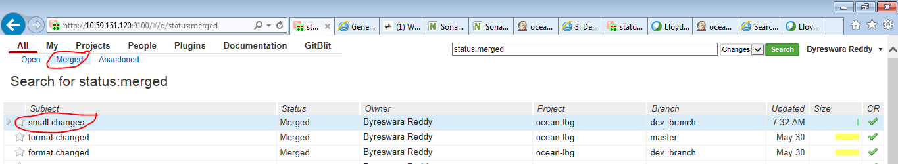

* Click on Cherry Pick and select master on popup window then click on Cherry Pick Change

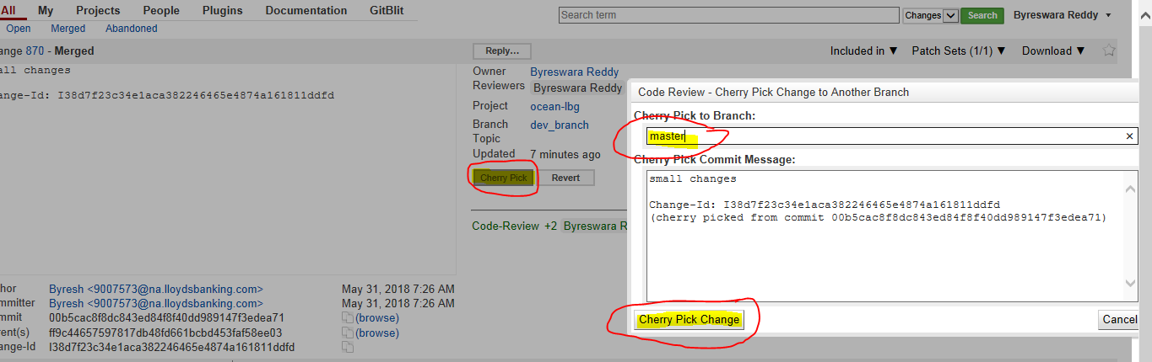

* Then it will come to Open status and ask to get +1 review.

**Option-2:**

If you see cherry pick conflict in Gerrit GUI click continue (see below screen shot) and we need to resolve and push it from Design studio

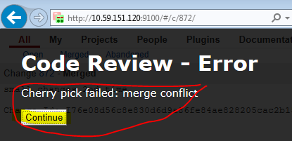

* Checkout to master branch in local (double click on master) see below screen shot
* Click Ok on popup window

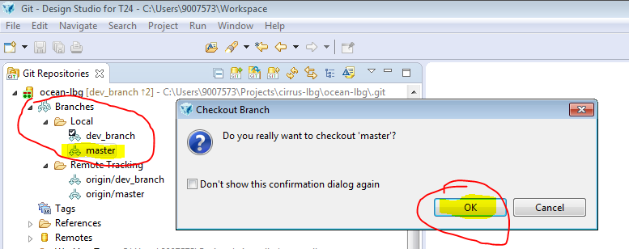

* You can observe TICK mark on master branch (i.e..,you have successfully checked out to master)

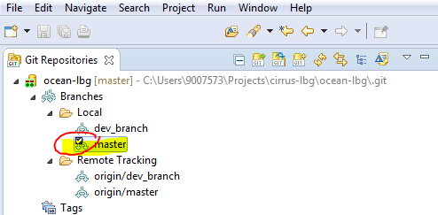

* Right click on ocean-lbg (check below screen shot) and select Fetch From Upstream

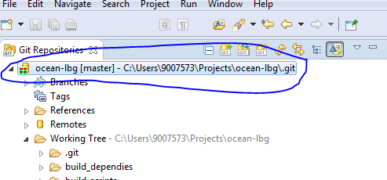

* Right click on ocean-lbg (check below screen shot) and select Rebase...



* Select origin/master and click on Rebase
* Click on Ok on popup window

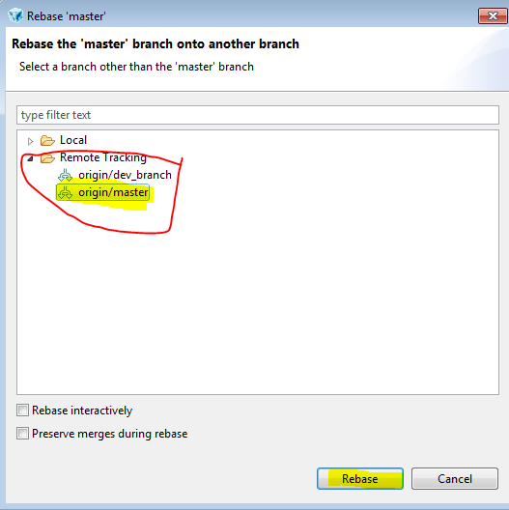

If you see below window (conflict) then check on Skip this commit and continue rebasing the next commits and click OK.

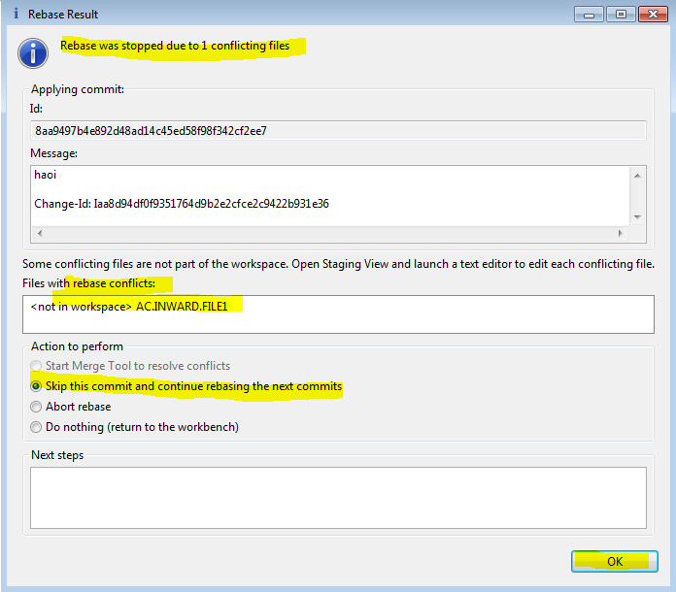

HOW TO MERGE TO MASTER USING CHERRY PICK:

* Right click on ocean-lbg and select Show In -> History
* You can see History and click on show all branches and tags icon (check below screen shot)
* Then you can see dev_branch history also

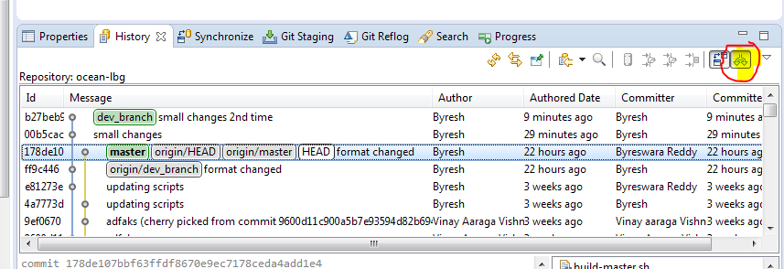

* Right click on commit which you want merge to master and select Cherry Pick…
* Then observe master on popup window then click Ok

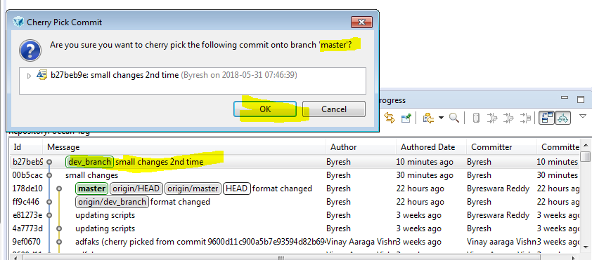

* You can see conflict warning, just click Ok to resolve.

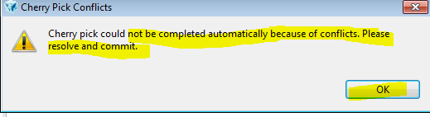

* Right click on routines and select Open Working Tree Version then resolve conflicts and Save it. i.e.., **you can find routines on bottom right corner** (see below screen shot)

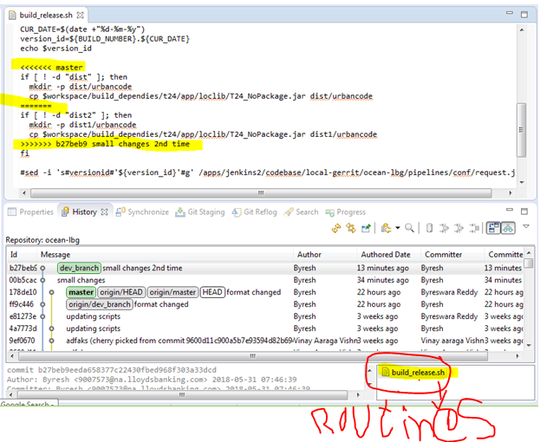

* Do it for other routines if any
* You can see conflict indicating symbols

<<< Master

===========

>>>>>>>>>b27be... small changes 2nd time

* above equal line code is latest ( remote changes) and below equal line code is your changes
* keep code which you want push to remote and remove remaining code and also remove conflict indicating symbol lines ( <<< master , =====, >>> >> b27be... )
* Click on Git Staging
* Drag routines from Unstaged changes to staged changes
* Write appropriate commit message
* And click on Commit and Push
* Observe master branch on popup window (see below screen shots)

NOTE: Push Only cherry pick commits to master

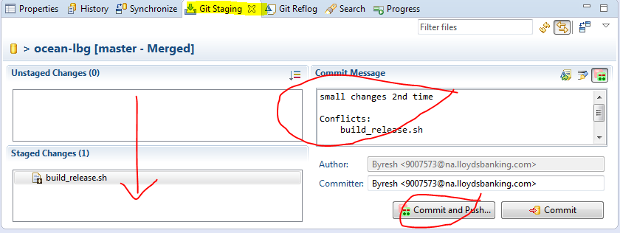

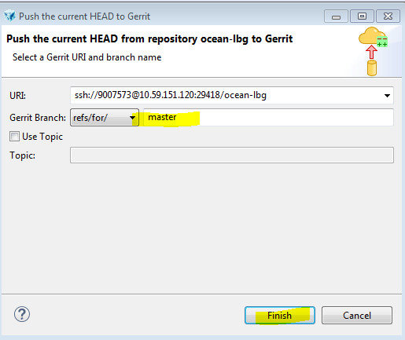

* Checkout to dev_branch in local (double click on dev_branch) see below screen shot
* Click Ok on popup window

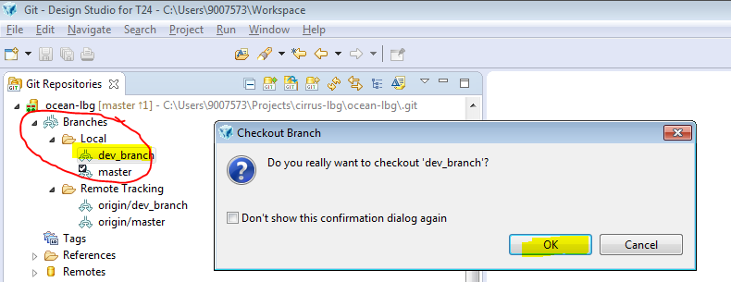

* You can observe TICK mark on dev_branch (i.e.., you have successfully checked out to master)

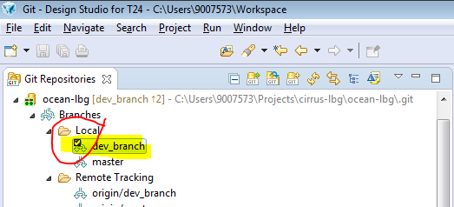

* You can see pushed routines in Gerrit GUI

